Afternoon Holy Communion Service St. John’s Lutheran Church
November 14, 2024, 3 p.m. Divine Service Two, page 167ff. Red Bud, Illinois
THE PRELUDE: “Old Hundredth” arranged by Wilbur Held
THE RINGING OF THE BELL calls us to holy worship.

OPENING HYMN: 791 “All People That on Earth Do Dwell”
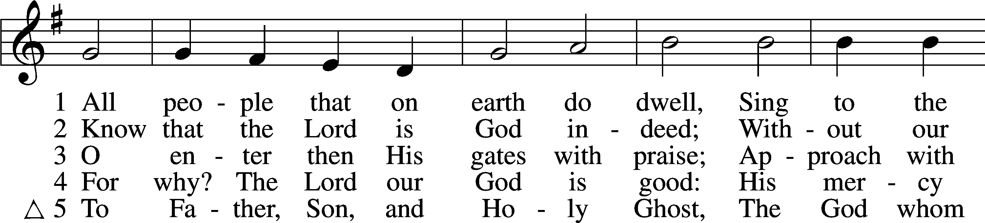
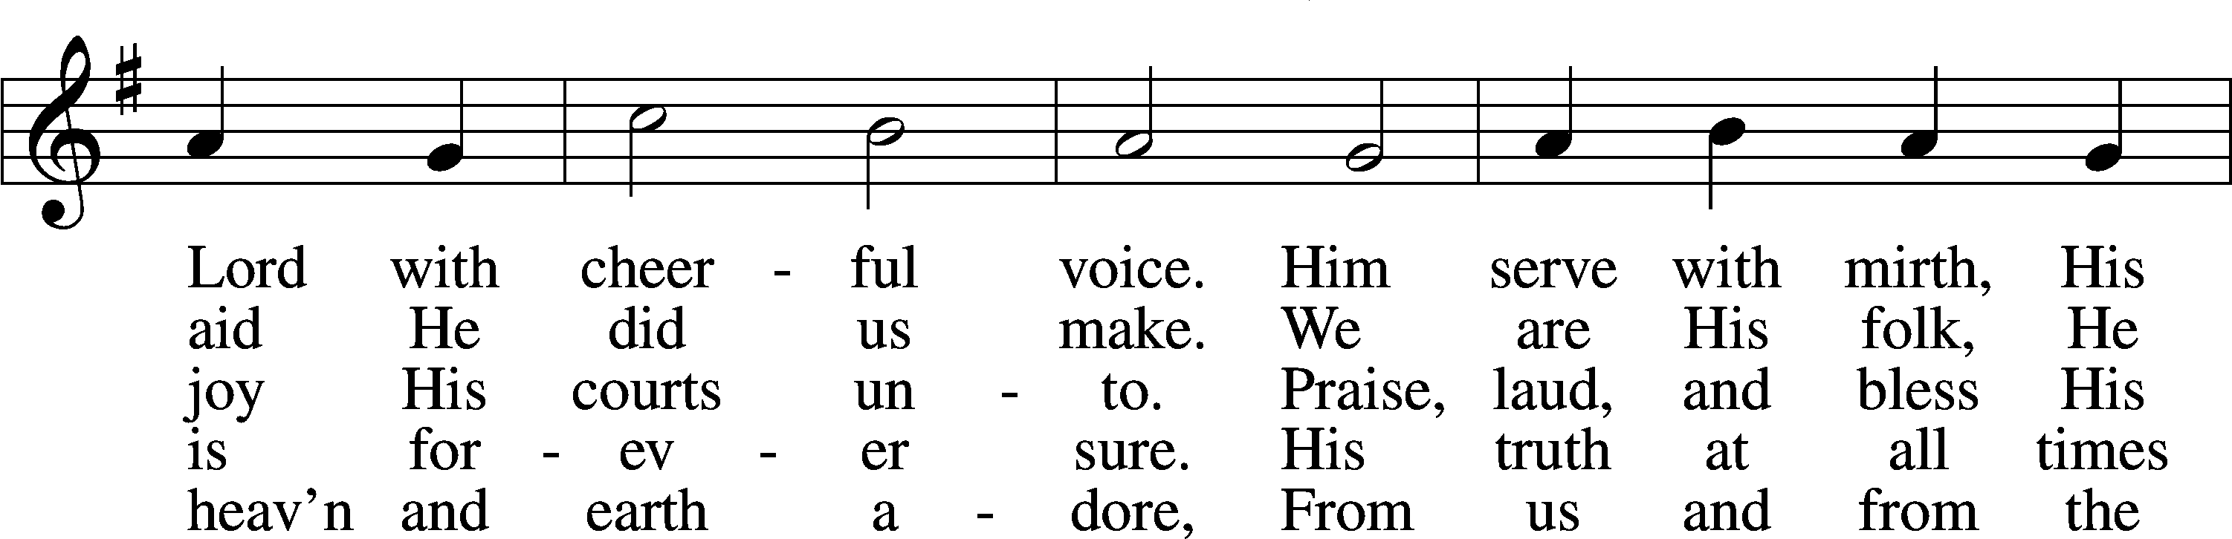
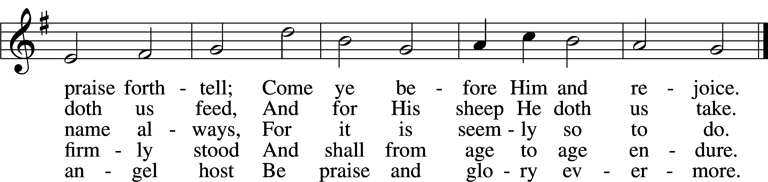
CONFESSION AND ABSOLUTION:
P: In the name of the Father and of the (+) Son and of the Holy Spirit. C: Amen.
P: If we say we have no sin, we deceive ourselves, and the truth is not in us.
C: But if we confess our sins, God, who is faithful and just, will forgive our sins and cleanse us from all unrighteousness.
Silence for reflection on God’s Word and for self-examination.
P: Let us then confess our sins to God our Father.
C: Most merciful God, we confess that we are by nature sinful and unclean. We have sinned against You in thought, word, and deed, by what we have done and by what we have left undone. We have not loved You with our whole heart; we have not loved our neighbors as ourselves. We justly deserve Your present and eternal punishment. For the sake of Your Son, Jesus Christ, have mercy on us. Forgive us, renew us, and lead us, so that we may delight in Your will and walk in Your ways to the glory of Your holy name. Amen.
P: Almighty God in His mercy has given His Son to die for you and for His sake forgives you all your sins. As a called and ordained servant of Christ, and by His authority, I therefore forgive you all your sins in the name of the Father and of the (+) Son and of the Holy Spirit. C: Amen.

INTROIT: Psalm 107: 1-2, 41-42; antiphon: v. 8
Let them thank the Lord for his | steadfast love,*
for his wondrous works to the chil- | dren of men!
Oh give thanks to the Lord, for | he is good,* for his steadfast love endures for- | ever!
Let the redeemed of the Lord | say so,* whom he has redeemed from | trouble.
He raises up the needy out of af- | fliction* and makes their families | like flocks.
The upright see it | and are glad,* and all wickedness | shuts its mouth.
Glory be to the Father and | to the Son* and to the Holy | Spirit;
as it was in the be- | ginning,* is now, and will be forever. | Amen.
Let them thank the Lord for his | steadfast love,*
for his wondrous works to the chil- | dren of men!
KYRIE: (page 168-169) (we sing the responses)
P: In peace let us pray to the Lord. C: Lord, have mer-cy.
P: For the peace from above and for our salvation let us pray to the Lord.
C: Lord, have mer-cy.
P: For the peace of the whole world, for the well-being of the Church of God, and for the unity of all let us pray to the Lord. C: Lord, have mer-cy.
P: For this holy house and for all who offer here their worship and praise let us pray to the Lord. C: Lord, have mer-cy.
P: Help, save, comfort, and defend us, gracious Lord. C: A-men.

HYMN OF PRAISE: “This Is the Feast” (pages 171-172)
P: This is the feast of victory for our God. Alleluia.
C: (sung) Wor-thy is Christ, the Lamb who was slain, whose blood set us free to be peo-ple of God. Pow-er and rich-es and wis-dom and strength and hon-or and bless-ing and glo-ry are His. This is the feast of vic-to-ry for our God. Al-le-lu-ia. Sing with all the peo-ple of God and join in the hymn of all cre-a-tion: Bless-ing and hon-or and glo-ry and might be to God and the Lamb for-ev-er. A-men. This is the feast of vic-to-ry for our God, for the Lamb who was slain has be-gun His reign. Al-le-lu-ia, al-le-lu-ia.

SALUTATION AND COLLECT OF THE DAY:
P: The Lord be with you. C: And also with you. P: Let us pray.
C: Almighty and ever-living God, You have given exceedingly great and precious promises to those who trust in You. Grant us so firmly to believe in Your Son Jesus that our faith may never be found wanting; through the same Jesus Christ, our Lord, who lives and reigns with You and the Holy Spirit, one God, now and forever. Amen.

THE OLD TESTAMENT READING: 1Kings 17: 8-16
8Then the word of the Lord came to [Elijah], 9“Arise, go to Zarephath, which belongs to Sidon, and dwell there. Behold, I have commanded a widow there to feed you.” 10So he arose and went to Zarephath. And when he came to the gate of the city, behold, a widow was there gathering sticks. And he called to her and said, “Bring me a little water in a vessel, that I may drink.” 11And as she was going to bring it, he called to her and said, “Bring me a morsel of bread in your hand.” 12And she said, “As the Lord your God lives, I have nothing baked, only a handful of flour in a jar and a little oil in a jug. And now I am gathering a couple of sticks that I may go in and prepare it for myself and my son, that we may eat it and die.” 13And Elijah said to her, “Do not fear; go and do as you have said. But first make me a little cake of it and bring it to me, and afterward make something for yourself and your son. 14For thus says the Lord the God of Israel, ‘The jar of flour shall not be spent, and the jug of oil shall not be empty, until the day that the Lord sends rain upon the earth.’” 15And she went and did as Elijah said. And she and he and her household ate for many days. 16The jar of flour was not spent, neither did the jug of oil become empty, according to the word of the Lord that he spoke by Elijah.
P: This is the Word of the Lord. C: Thanks be to God.

THE GRADUAL: Revelation 7: 14b; Psalm 84:5
These are the ones coming out of the great tribulation.
They have washed their robes and made them white in the blood of the Lamb.
Blessèd are those whose strength is in you,
in whose heart are the highways to Zion.

THE EPISTLE READING: Hebrews 9: 24-28
²⁴For Christ has entered, not into holy places made with hands, which are copies of the true things, but into heaven itself, now to appear in the presence of God on our behalf. ²⁵Nor was it to offer himself repeatedly, as the high priest enters the holy places every year with blood not his own, ²⁶for then he would have had to suffer repeatedly since the foundation of the world. But as it is, he has appeared once for all at the end of the ages to put away sin by the sacrifice of himself. ²⁷And just as it is appointed for man to die once, and after that comes judgment, ²⁸so Christ, having been offered once to bear the sins of many, will appear a second time, not to deal with sin but to save those who are eagerly waiting for him.
P: This is the Word of the Lord. C: Thanks be to God.

ALLELUIA and VERSE: (page 173) (sung)
Al-le-lu-ia. Lord, to whom shall we go? You have the words of e-ter-nal life.
Al-le-lu-ia, al-le-lu-ia.
THE HOLY GOSPEL: Mark 12: 38-44
P: The Holy Gospel according to St. Mark, the 12th chapter. C: Glo-ry to You, O Lord.
³⁸In his teaching [Jesus] said, “Beware of the scribes, who like to walk around in long robes and like greetings in the marketplaces ³⁹and have the best seats in the synagogues and the places of honor at feasts, ⁴⁰who devour widows’ houses and for a pretense make long prayers. They will receive the greater condemnation.”
⁴¹And he sat down opposite the treasury and watched the people putting money into the offering box. Many rich people put in large sums. ⁴²And a poor widow came and put in two small copper coins, which make a penny. ⁴³And he called his disciples to him and said to them, “Truly, I say to you, this poor widow has put in more than all those who are contributing to the offering box. ⁴⁴For they all contributed out of their abundance, but she out of her poverty has put in everything she had, all she had to live on.”
P: This is the Gospel of the Lord. C: Praise to You, O Christ.

OUR CONFESSION OF FAITH: Nicene Creed (page 174)
I believe in one God, the Father Almighty, maker of heaven and earth and of all things visible and invisible.
And in one Lord Jesus Christ, the only-begotten Son of God, begotten of His Father before all worlds, God of God, Light of Light, very God of very God, begotten, not made, being of one substance with the Father, by whom all things were made; who for us men and for our salvation came down from heaven and was incarnate by the Holy Spirit of the virgin Mary and was made man; and was crucified also for us under Pontius Pilate. He suffered and was buried. And the third day He rose again according to the Scriptures and ascended into heaven and sits at the right hand of the Father. And He will come again with glory to judge both the living and the dead, whose kingdom will have no end.
And I believe in the Holy Spirit, the Lord and giver of life, who proceeds from the Father and the Son, who with the Father and the Son together is worshiped and glorified, who spoke by the prophets. And I believe in one holy Christian and apostolic Church, I acknowledge one Baptism for the remission of sins, and I look for the resurrection of the dead and the life of the world to come. Amen.

HYMN OF THE DAY: 787 “The Temple Rang with Golden Coins”
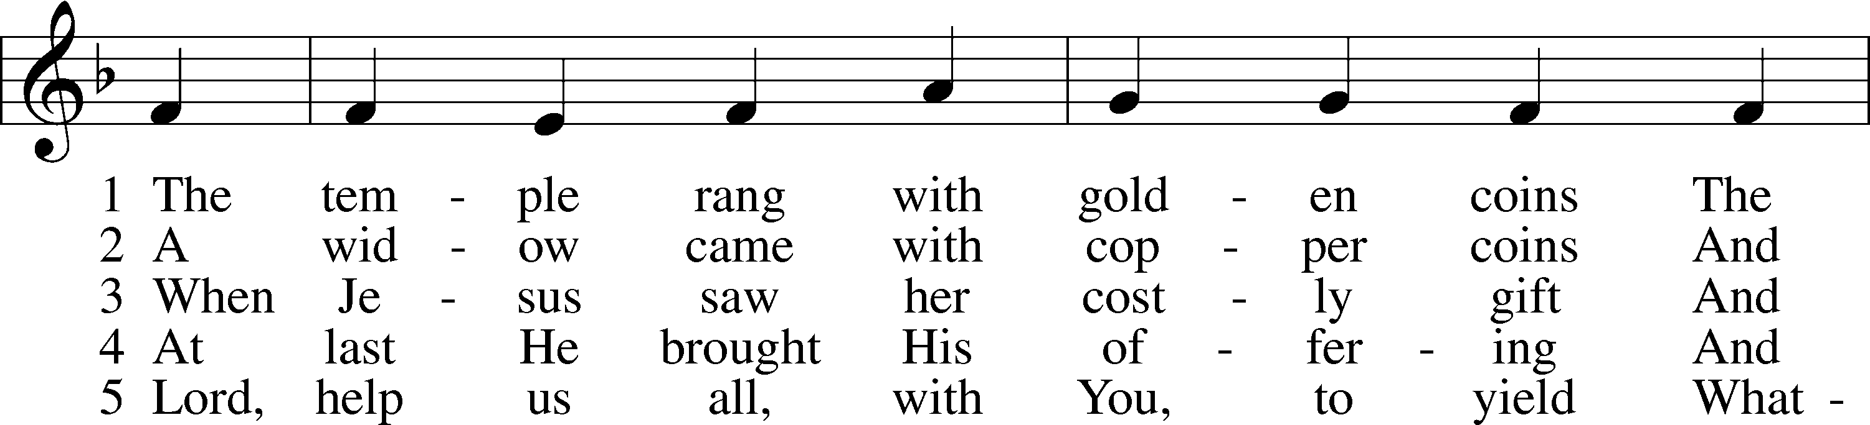
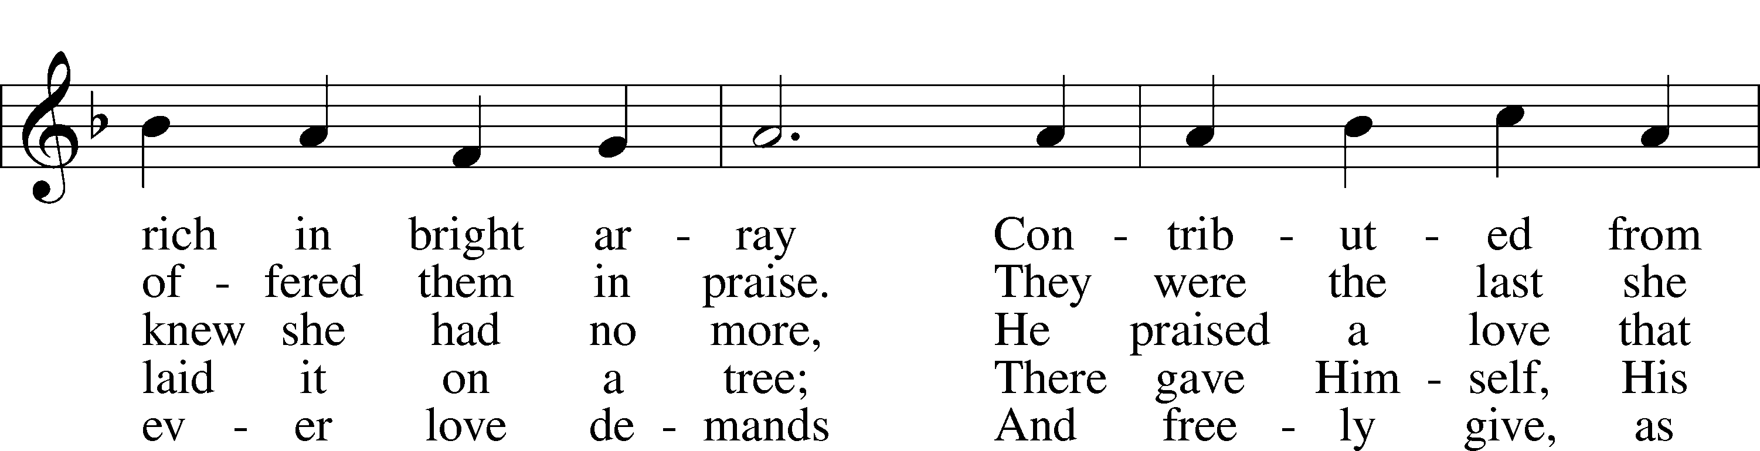
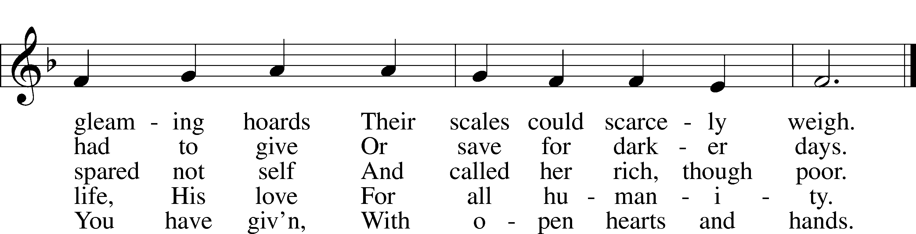

SERMON: “How to Strengthen Our Thread!” Hebrews 9: 24-28

PRAYER OF THE CHURCH
(Each petition ends, “Lord, in Your mercy,” and we respond, “hear our prayer.”)

SERVICE OF THE SACRAMENT: page 177ff.

PREFACE: (we speak the responses) (page 177)
P: The Lord be with you. C: And also with you.
P: Lift up your hearts. C: We lift them to the Lord.
P: Let us give thanks to the Lord our God. C: It is right to give Him thanks and praise.
P: It is truly good, right, and salutary that we should at all times and in all places give thanks to You, holy Lord, almighty Father, everlasting God, through Jesus Christ, our Lord, who on this day overcame death and the grave and by His glorious resurrection opened to us the way of everlasting life. Therefore, with 10 angels and archangels and with all the company of heaven we laud and magnify Your glorious name, evermore praising You and saying:

Sanctus: (page 178) (sung)
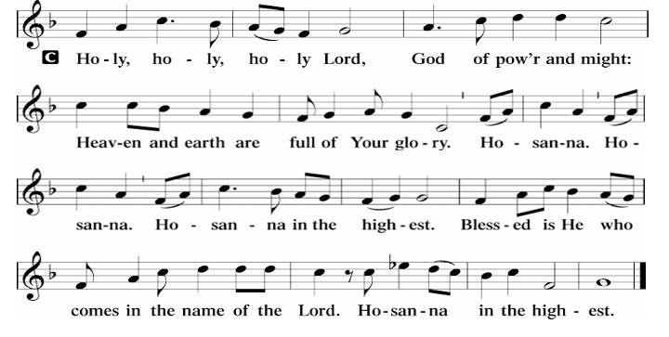
Prayer of Thanksgiving: (page 178)
P: Blessed are You, Lord of heaven and earth, for You have had mercy on those whom You created and sent Your only-begotten Son into our flesh to bear our sin and be our Savior. With repentant joy we receive the salvation accomplished for us by the all availing sacrifice of His body and His blood on the cross.
Gathered in the name and the remembrance of Jesus, we beg You, O Lord, to forgive, renew, and strengthen us with Your Word and Spirit. Grant us faithfully to eat His body and drink His blood as He bids us do in His own testament. Gather us together, we pray, from the ends of the earth to celebrate with all the faithful the marriage feast of the Lamb in His kingdom, which has no end. Graciously receive our prayers; deliver and preserve us. To You alone, O Father, be all glory, honor, and worship, with the Son and the Holy Spirit, one God, now and forever. C: Amen.

Lord's Prayer, the Words of Our Lord and the Pax Domini: (pages 179-180)
P: Lord, remember us in Your kingdom and teach us to pray:
C: Our Father who art in heaven, hallowed be Thy name, Thy kingdom come, Thy will
be done on earth as it is in heaven; give us this day our daily bread; and forgive us our trespasses as we forgive those who trespass against us; and lead us not into temptation, but deliver us from evil. For Thine is the kingdom and the power and the glory forever and ever. Amen.
P: The peace of the Lord be with you always. C: A-men.

Agnus Dei: (sung) (page 180)
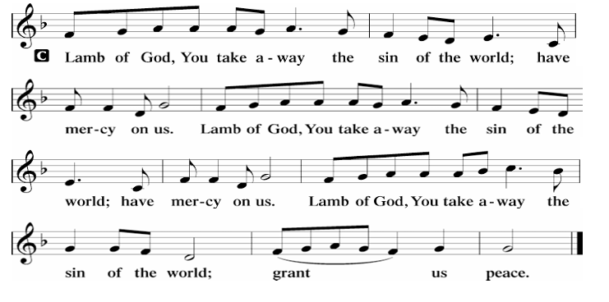

POST-COMMUNION COLLECT & BENEDICTION: (page 183)
P: Let us pray. O God the Father, the fountain and source of all goodness, who in loving-kindness sent Your only-begotten Son into the flesh, we thank You that for His sake You have given us pardon and peace in this Sacrament, and we ask You not to forsake Your children but always to rule our hearts and minds by Your Holy Spirit that we may be enabled constantly to serve You; through Jesus 14 Christ, Your Son, our Lord, who lives and reigns with You and the Holy Spirit, one God, now and forever. C: Amen.
P: The Lord bless you and keep you. The Lord make His face shine on you and be gracious to you. The Lord look upon you with favor and (+) give you peace. C: A-men.

CLOSING HYMN: 809 “Great is Thy Faithfulness”
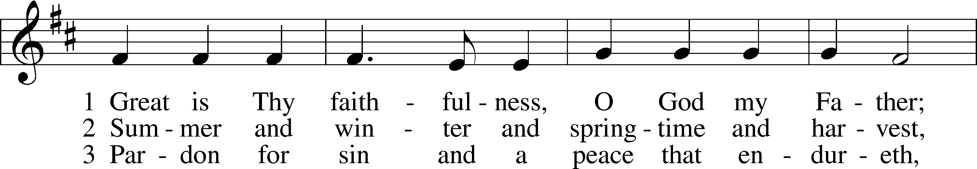
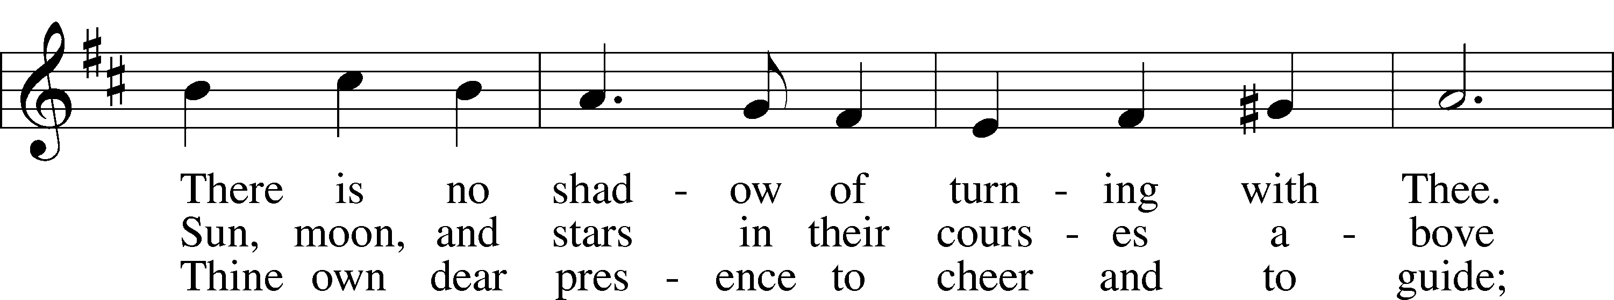
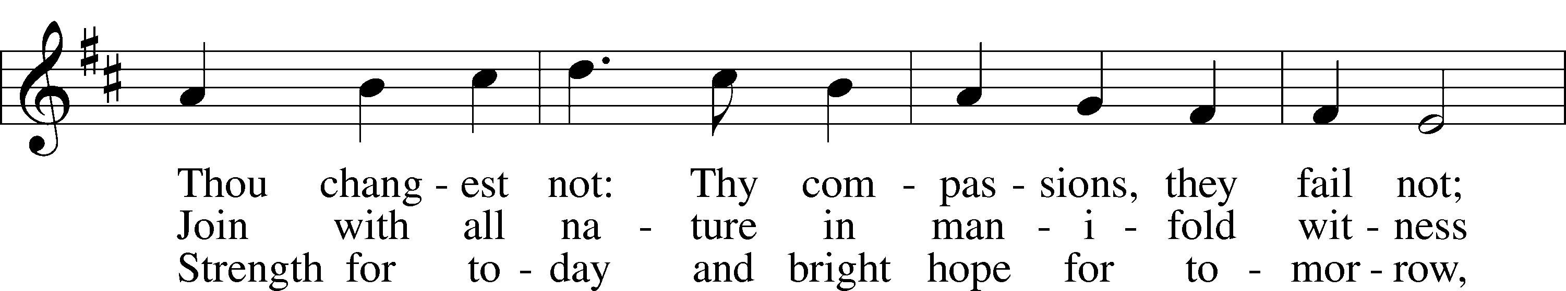
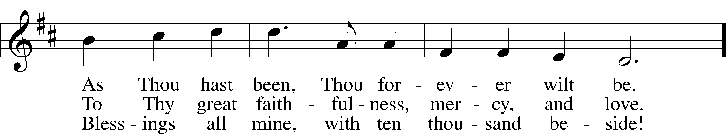
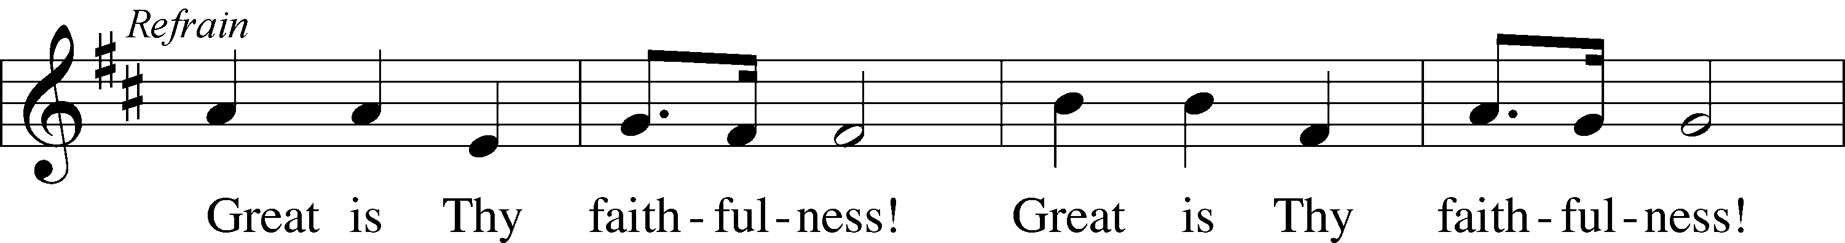
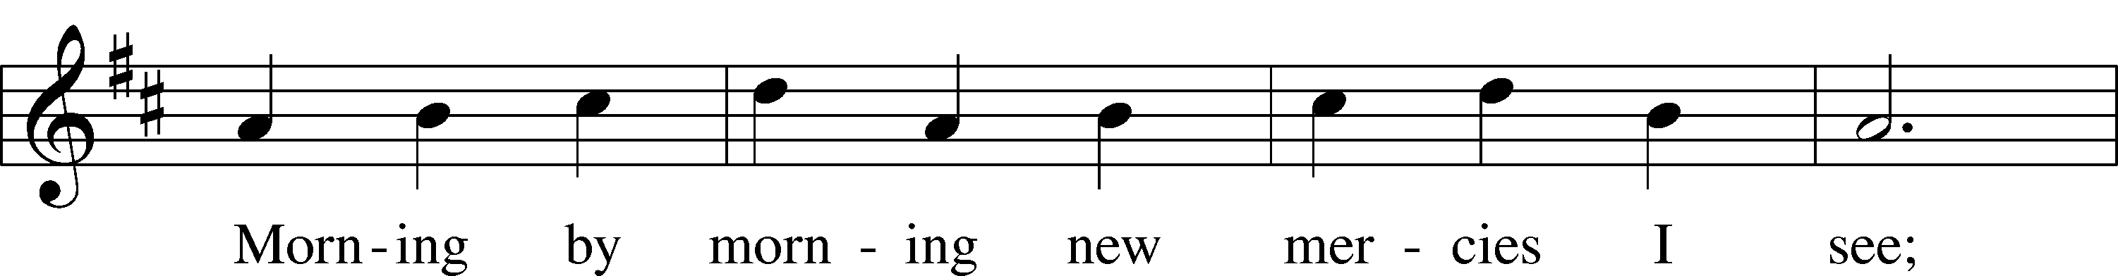
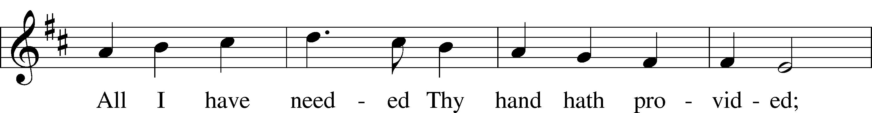
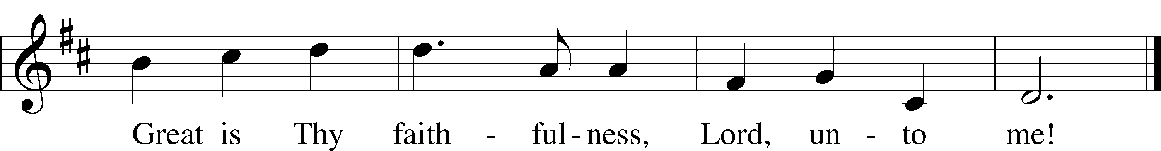

POSTLUDE: “Faithfulness” arranged by Mark E. Bloedow

Acknowledgments Divine Service, Setting Two from Lutheran Service Book Unless otherwise indicated, all scripture quotations are from The Holy Bible, English Standard Version, copyright © 2001 by Crossway Bibles, a division of Good News Publishers. Used by permission. All rights reserved. Created by Lutheran Service Builder © 2024 Concordia Publishing House.

