The Eleventh Sunday After Pentecost St. John’s Lutheran Church
August 15 & 16, 2020 Red Bud, Illinois
Divine Service Three, page 184ff.
PRELUDE: “Rejoice, O Pilgrim Throng” arranged by Allan Mahnke
THE RINGING OF THE BELL calls us to holy worship.
WELCOME TO ST. JOHN’S LUTHERAN CHURCH! We preach the Gospel of Jesus Christ, administer the sacraments and provide Christian education in service to all people. We are especially happy that we have visitors with us today. St. John’s is a congregation which follows the historic order of Christian worship. Even if you are not Lutheran, you may recognize many of the elements of worship from your own tradition. If you or your small child needs a space for privacy during the service, Room 1 in the Fellowship Hall has a TV with a video feed of our worship service. We ask everyone to sign our Friendship Register that is at the end of the pew. To honor the reverent nature of our worship, please silence and do not use your cell phones and pagers during this service. Thank you!

Opening Hymn: 832 “Jesus Shall Reign”
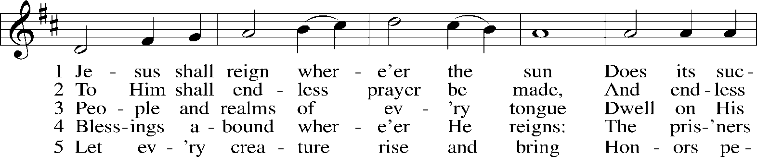
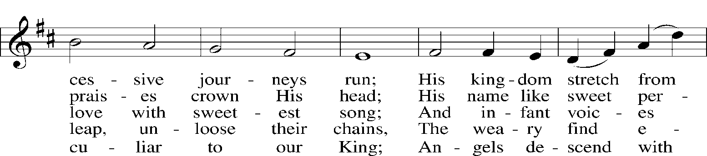
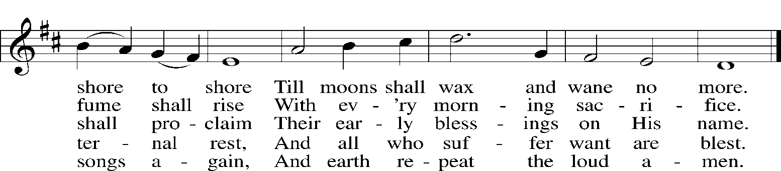
Public domain
(please stand if you are able)
P In the name of the Father and of the (+) Son and of the Holy Spirit. C Amen.
P Beloved in the Lord! Let us draw near with a true heart and confess our sins unto God our Father, beseeching Him in the name of our Lord Jesus Christ to grant us forgiveness.
P Our help is in the name of the Lord, C who made heaven and earth.
P I said, I will confess my transgressions unto the Lord,
C and You forgave the iniquity of my sin.
P O almighty God, merciful Father,
C I, a poor, miserable sinner, confess unto You all my sins and iniquities with which I have ever offended You and justly deserved Your temporal and eternal punishment. But I am heartily sorry for them and sincerely repent of them, and I pray You of Your boundless mercy and for the sake of the holy, innocent, bitter sufferings and death of Your beloved Son, Jesus Christ, to be gracious and merciful to me, a poor, sinful being.
P Upon this your confession, I, by virtue of my office, as a called and ordained servant of the Word, announce the grace of God unto all of you, and in the stead and by the command of my Lord Jesus Christ I forgive you all your sins in the name of the Father and of the (+) Son and of the Holy Spirit. C Amen.

Introit: Psalm 28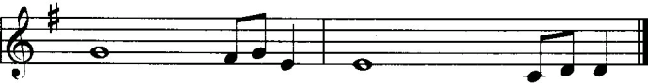
The Lord is the strength of His | people; He is the saving refuge of His a- | nointed.
To You, O / Lord, I call; be not | deaf to me,
if You be si- / lent to me, I become like those who go down | to the pit.
Hear my pleas for / mercy when I cry to | You for help,
when I lift / up my hands toward Your most holy sanctu- | ary.
Blessèd | be the Lord! He has heard the voice of my pleas for | mercy.
The Lord is my strength / and my shield; in Him my heart trusts, and | I am helped;
my heart exults, and / with my song I give | thanks to Him.
C Glory be to the Father and to the Son and to the Holy Ghost; as it was in the beginning, is now, and ever shall be, world without end. Amen.
Kyrie (sung)
Lord, have mercy upon us. Christ, have mercy upon us. Lord, have mercy upon us.
Gloria in Excelsis page 187
P Glory be to God on high: C and on earth peace, goodwill toward men.
We praise Thee, we bless Thee, we worship Thee,
we glorify Thee, we give thanks to Thee, for Thy great glory.
O Lord God, heav’nly King, God the Father Almighty.
O Lord, the only-begotten Son, Jesus Christ;
O Lord God, Lamb of God, Son of the Father,
that takest away the sin of the world, have mercy upon us.
Thou that takest away the sin of the world, receive our prayer.
Thou that sittest at the right hand of God the Father, have mercy upon us.
For Thou only art holy; Thou only art the Lord.
Thou only, O Christ, with the Holy Ghost,
art most high in the glory of God the Father. Amen.

Salutation and Collect of the Day
P The Lord be with you. C (sung) And with thy spirit.
P Let us pray together the Collect of the Day.
Almighty and everlasting Father, You give Your children many blessings even though we are undeserving. In every trial and temptation grant us steadfast confidence in Your loving-kindness and mercy; through Jesus Christ, Your Son, our Lord, who lives and reigns with You and the Holy Spirit, one God, now and forever. Amen. (please be seated)

(8 a.m.) Anthem: “Brothers and Sisters in Christ” Summer Singers
The Old Testament Reading: Isaiah 56:1, 6-8
Thus says the Lord: “Keep justice, and do righteousness, for soon My salvation will come, and My deliverance be revealed. “And the foreigners who join themselves to the Lord, to minister to Him, to love the name of the Lord, and to be His servants, everyone who keeps the Sabbath and does not profane it, and holds fast My covenant— these I will bring to My holy mountain, and make them joyful in My house of prayer; their burnt offerings and their sacrifices will be accepted on My altar; for My house shall be called a house of prayer for all peoples.” The Lord God, who gathers the outcasts of Israel, declares, “I will gather yet others to him besides those already gathered.”
A This is the Word of the Lord. C Thanks be to God.
The Gradual
Fear the Lord, you His saints, for those who fear Him lack nothing!
Many are the afflictions of the righteous, but the Lord delivers him out of them all.

The Epistle Reading: Romans 11:1-2a, 13-15, 28-32
I ask, then, has God rejected His people? By no means! For I myself am an Israelite, a descendant of Abraham, a member of the tribe of Benjamin. God has not rejected His people whom He foreknew. Do you not know what the Scripture says of Elijah, how he appeals to God against Israel? Now I am speaking to you Gentiles. Inasmuch then as I am an apostle to the Gentiles, I magnify my ministry in order somehow to make my fellow Jews jealous, and thus save some of them. For if their rejection means the reconciliation of the world, what will their acceptance mean but life from the dead?
As regards the gospel, they are enemies of God for your sake. But as regards election, they are beloved for the sake of their forefathers. For the gifts and the calling of God are irrevocable. Just as you were at one time disobedient to God but now have received mercy because of their disobedience, so they too have now been disobedient in order that by the mercy shown to you they also may now receive mercy. For God has consigned all to disobedience, that He may have mercy on all.
A This is the Word of the Lord. C Thanks be to God.

Please Stand if you are able Alleluia (sung)
C Alleluia. Alleluia. Alleluia.

THE HOLY GOSPEL: Matthew 15:21-28
P The Holy Gospel according to St. Matthew, the fifteenth chapter.
C (sung) Glory be to Thee, O Lord.
Jesus went away from there and withdrew to the district of Tyre and Sidon. And behold, a Canaanite woman from that region came out and was crying, “Have mercy on me, O Lord, Son of David; my daughter is severely oppressed by a demon.” But He did not answer her a word. And His disciples came and begged Him, saying, “Send her away, for she is crying out after us.” He answered, “I was sent only to the lost sheep of the house of Israel.” But she came and knelt before Him, saying, “Lord, help me.” And He answered, “It is not right to take the children’s bread and throw it to the dogs.” She said, “Yes, Lord, yet even the dogs eat the crumbs that fall from their masters’ table.” Then Jesus answered her, “O woman, great is your faith! Be it done for you as you desire.” And her daughter was healed instantly.
P This is the Gospel of the Lord. C (sung) Praise be to Thee, O Christ.
The Nicene Creed
I believe in one God, the Father Almighty, maker of heaven and earth and of all things visible and invisible.
And in one Lord Jesus Christ, the only-begotten Son of God, begotten of His Father before all worlds, God of God, Light of Light, very God of very God, begotten, not made, being of one substance with the Father, by whom all things were made; who for us men and for our salvation came down from heaven and was incarnate by the Holy Spirit of the virgin Mary and was made man; and was crucified also for us under Pontius Pilate. He suffered and was buried. And the third day He rose again according to the Scriptures and ascended into heaven and sits at the right hand of the Father. And He will come again with glory to judge both the living and the dead, whose kingdom will have no end.
And I believe in the Holy Spirit, the Lord and giver of life, who proceeds from the Father and the Son, who with the Father and the Son together is worshiped and glorified, who spoke by the prophets. And I believe in one holy Christian and apostolic Church, I acknowledge one Baptism for the remission of sins, and I look for the resurrection of the dead and the life of the world to come. Amen. (please be seated)

HYMN OF THE DAY: 653 “In Christ There Is No East or West” 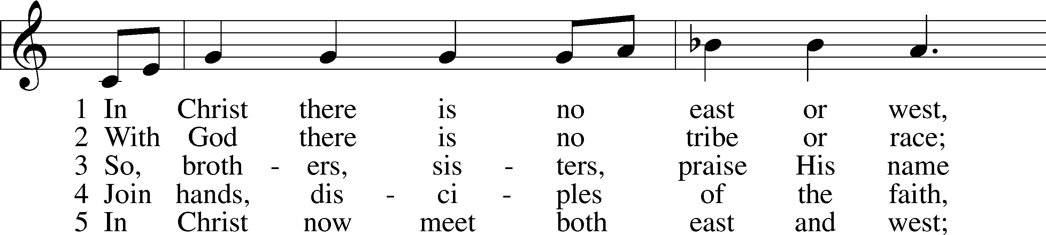
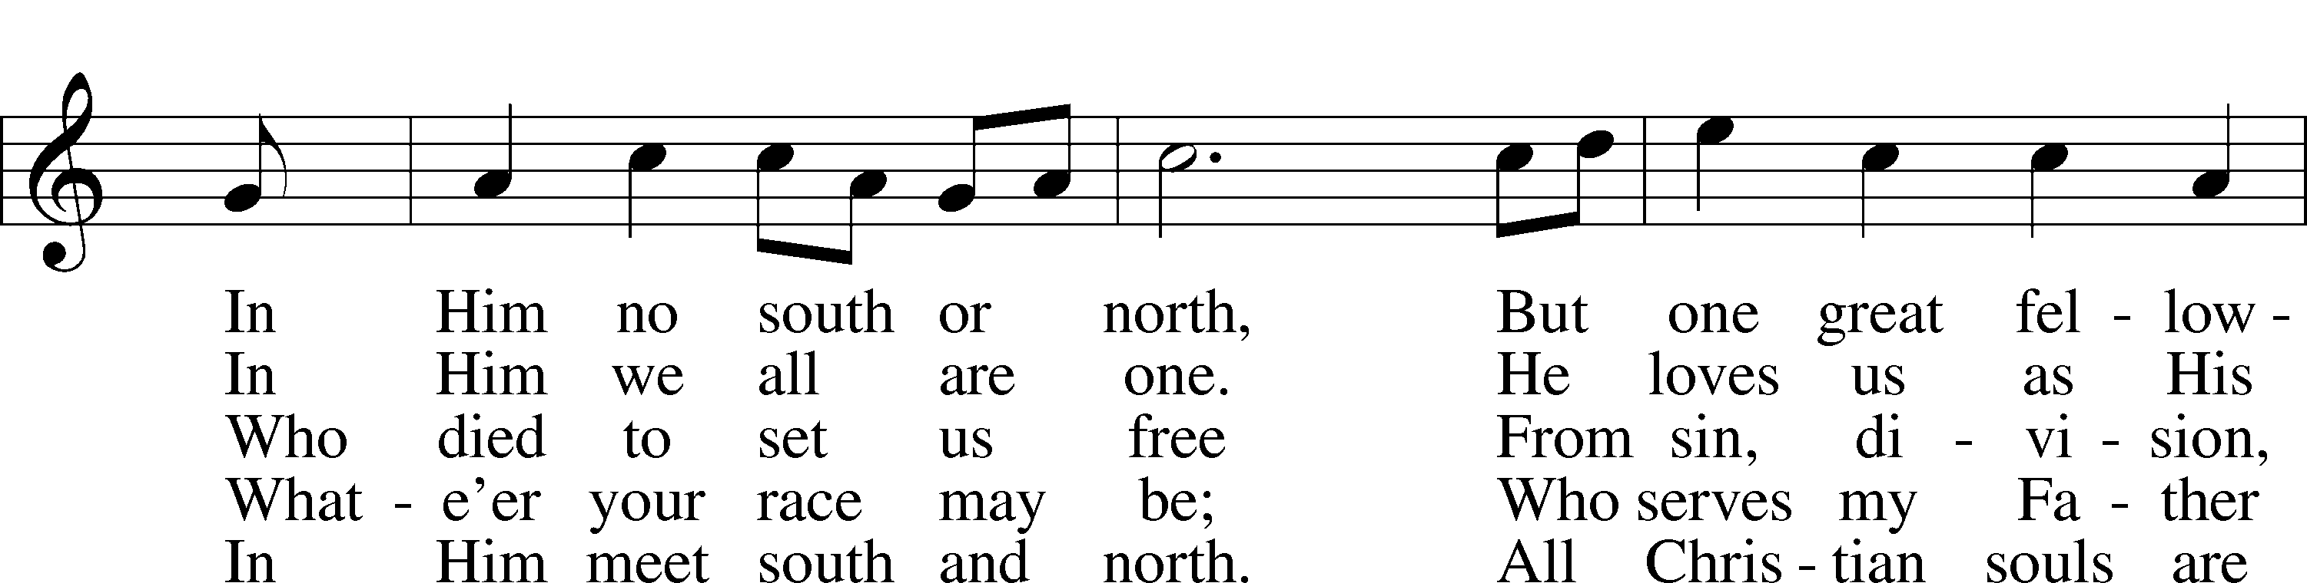
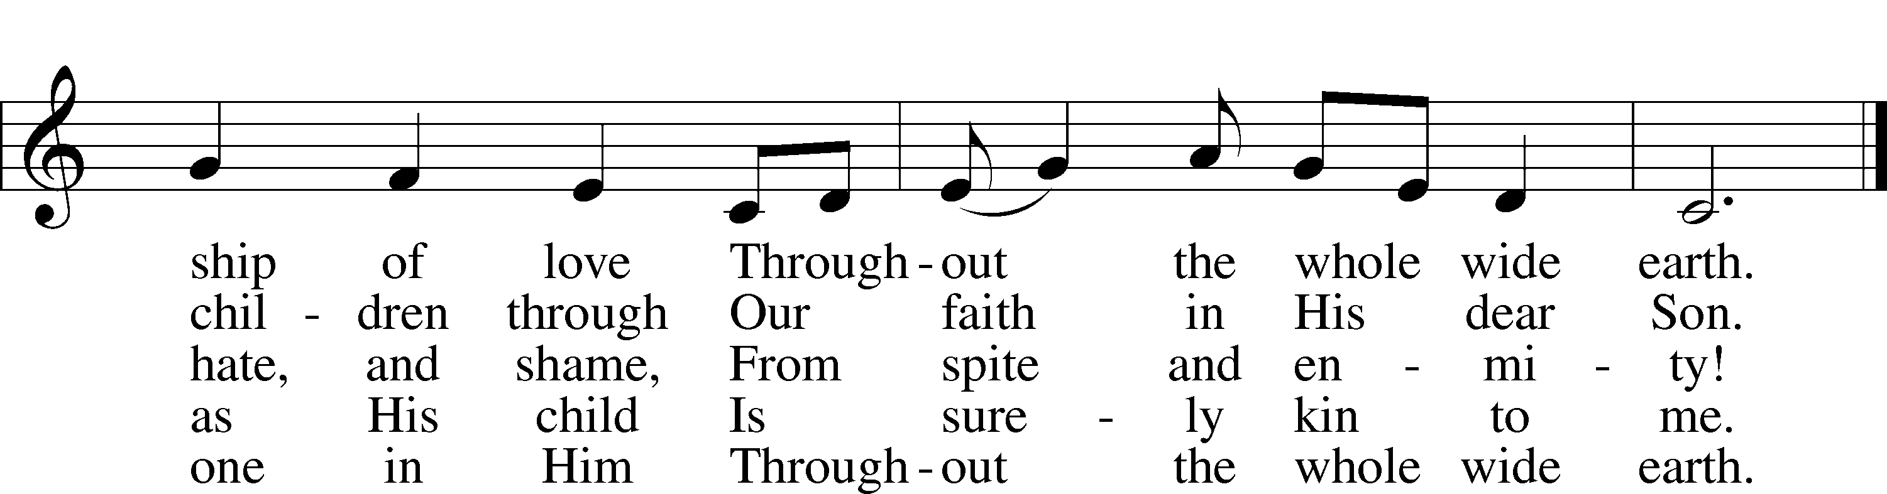
admin. Hope Publishing Co. Used by permission: LSB Hymn License .NET, no. 100012179.; © 1993 Mark A. Jeske; © 1982 Jubilate Hymns Ltd. Public domain

SERMON: “Not Only, But All”
- Only the Lost Sheep of Israel (Matthew 15:24)
- He May Have Mercy on All (Romans 11:32)
- My House Shall Be Called a House of Prayer for All Nations (Isaiah 56:7)
(Please stand if you are able) Offertory (sung)
Create in me a clean heart, O God, and renew a right spirit within me.
Cast me not away from Thy presence, and take not Thy Holy Spirit from me.
Restore unto me the joy of Thy salvation, and uphold me with Thy free spirit. Amen.

Prayer of the Church
HEALING AND COMFORT: Edna Moeller, Cecelia Lautenschlaeger, Doris Mueller, Wanda Steele, C. John Prigge, Ed Luttman, Curtis Hartmann, Gary Moeller, Larry Ebers, Lori Rees, JoAnna Ellner, Cliff Crafton; Family and Friends of St. John’s Members: Lori Voges, Brenda Manning, Cheryl Zanders, Gena Triefenbach, Kent Henke, A.J. Guebert, Angie Cloughly, Roger Drinnon, Sr., Daniel Snyder, Ruth Hecht, James Sitzes, Rev. Timothy Scharr, Agatha Reinhardt. Help us keep this list current!
MILITARY: (Please call with names.) Army- Casey Vallett, Tanner Valleroy, Nathan Koen, Tim Healy, Jacob Adams, Donald Roberts, Matthew Kraus, Paul Craft, Jr., Dustin Krack, Austin Scheibe, Trevor Buckner, Jessica DeMarco, Jeremiah Brandt, Benjamin Boeder, Christopher Dupertius, Garrett Carnahan, Tyler Wahlman, Gavin Roche-Voss, Joshua Cox; Navy- Brad Koester, Carl Muehler; Air Force- Gage Baldwin, Brian Hubbard, Jason Nehrt, Curt Hatten, Terry Koester, David Livingston, Matt Sabo, Ryan Kozarich; Marines- Alex Renner, Cody Koch, Tailor Neuhaus, Josh Butterworth, Brent Knop, Keenan Turnure
+for all local schools, teachers, students, staff, parents, including our own St. John’s Elementary & Christ Our Savior LHS
+those suffering from the coronavirus and the effects of it on our society
+our nation as it continues to suffer from division, violence and unrest in our cities

Let us pray to the Lord for all that we need and on behalf of all people, that He may bestow upon us the riches of His grace and that we may receive His gifts with faith and thanksgiving in our hearts. Brief silence

For true unity in the faith; for the preservation of pure doctrine; for harmony in the lives of our congregation, district and Synod; and for charitable hearts that put the best construction on what we see and hear, let us pray to the Lord: Lord, have mercy.

For those outside the kingdom; for missionaries near and far; for the ministries and agencies of our Church whereby the Gospel is spoken to those who have not heard; and for those who hear, that they may be brought to faith, let us pray to the Lord: Lord, have mercy.

For God’s blessings during these difficult days to be upon all our local schools as they open this week as important places where children learn, teachers instruct, staff serves and parents provide, especially remembering the schools, universities and seminaries of our church including our own St. John’s Elementary and Christ Our Savior Lutheran High School, let us pray to the Lord: Lord, have mercy.

For all families, for husbands and wives to live in faithfulness to each other, for all mothers with child, for all children, and for those who bring them to Baptism and nurture them in the faith, let us pray to the Lord: Lord, have mercy.

For our president; the Congress; our governor; all elected and appointed leaders; all judges and magistrates; especially during this time of violence and civil unrest in our cities that our Lord would guide all elected and appointed civil servants in their judgments, that we may know justice in our land and peace among the nations, thankful for the service of the members of the armed forces our police, firefighters and emergency medical personnel in their duties to protect and serve us, let us pray to the Lord: Lord, have mercy.

For the healing of the sick, the relief of the suffering, the comfort of the grieving and the peace of the dying, and for those who care for them in their afflictions especially do we remember Edna, Cecelia, Doris, Wanda, C. John, Ed, Gary, Larry, Lori, JoAnna, Cliff, Lori, Brenda, Cheryl, Gena, Kent, A.J., Angie, Roger, Daniel, Ruth, Jim, Rev. Scharr, Agatha and all those we name in our hearts including all those suffering or recovering from the tragedy of this COVID-19 pandemic, let us pray to the Lord: Lord, have mercy.

For this holy assembly and for our communion upon the Lord’s body and blood, and for us to bear in our lives the fruits of the Spirit and do the good works for which we were created, let us pray to the Lord: Lord, have mercy.

For all honest work and occupations, for our good use of the fruits of our labors, for generosity for those in need, and for the tithes and offerings that accompany our sacrifice of praise and thanksgiving, let us pray to the Lord: Lord, have mercy.

Lord God, giver of all that is good, mercifully hear the prayers of Your people and grant us Your grace, that we may endure the changes and chances of this mortal life and be found worthy when our Savior comes to bring to completion all things; through Jesus Christ, our Lord, who lives and reigns with You and the Holy Spirit, one God, now and forever. Amen.

WE CELEBRATE HOLY COMMUNION: In this Supper of our Lord we receive the true body and blood of our Lord Jesus Christ under the earthly forms of bread and wine for the forgiveness of our sins and the strengthening of our faith. Since this Holy Communion is also a sign of how we commonly confess the Christian faith, we welcome to the Lord’s Table those who are confirmed members of congregations of The Lutheran Church-Missouri Synod. The individual cups of white wine in the center of the cup tray contain non-alcoholic wine for those who prefer this. Place a finger to your lips if you prefer an individual cup. For more information about this sacrament, please see pages 326-327 and 329-330 of Lutheran Service Book.
Service of the Sacrament
Preface (we sing the responses)
P The Lord be with you. C And with thy spirit.
P Lift up your hearts. C We lift them up unto the Lord.
P Let us give thanks unto the Lord our God.
C It is meet and right so to do.
P It is truly meet, right, and salutary that we should at all times and in all places give thanks to You, holy Lord, almighty Father, everlasting God. Through Jesus Christ, our Lord, who out of love for His fallen creation, humbled Himself by taking on the form of a servant, becoming obedient unto death, even death upon a cross. Risen from the dead, He has freed us from eternal death and given us everlasting life. Therefore with angels and archangels, and with all the company of heaven we laud and magnify Your glorious name, evermore praising You and saying:
Sanctus (sung)
C Holy, holy, holy Lord God of Sabaoth; heav'n and earth are full of Thy glory.
Hosanna, hosanna, hosanna in the highest.
Blessed is He, blessed is He, blessed is He that cometh in the name of the Lord. Hosanna, hosanna, hosanna in the highest.

Lord's Prayer
P Our Father who art in heaven, hallowed be Thy name, Thy kingdom come,
Thy will be done on earth as it is in heaven; give us this day our daily bread;
and forgive us our trespasses as we forgive those who trespass against us;
and lead us not into temptation, but deliver us from evil.
(sung) For Thine is the kingdom and the power and the glory forever and ever. A-men.

The Words of Our Lord and Pax Domini
P …The peace of the Lord be with you always. C (sung) A-men.
Agnus Dei (sung)
C O Christ, Thou Lamb of God, that takest away the sin of the world, have mercy upon us. O Christ, Thou Lamb of God, that takest away the sin of the world, have mercy upon us. O Christ, Thou Lamb of God, that takest away the sin of the world, grant us Thy peace. A-men. (please be seated)

Distribution Hymn: 619 “Thy Body, Given for Me, O Savior”
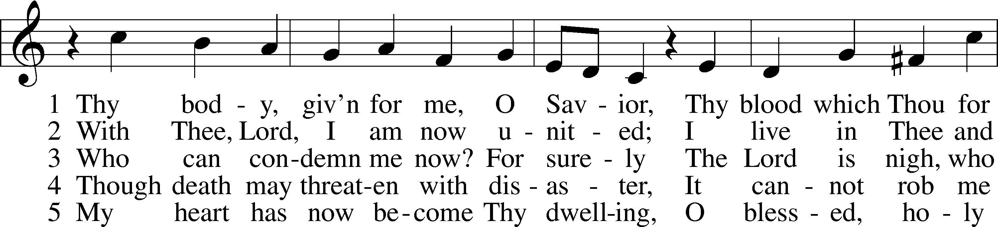
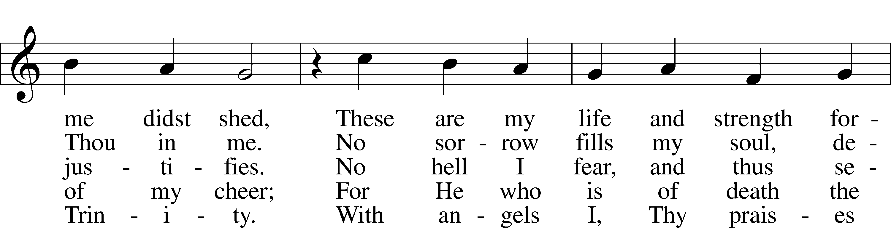
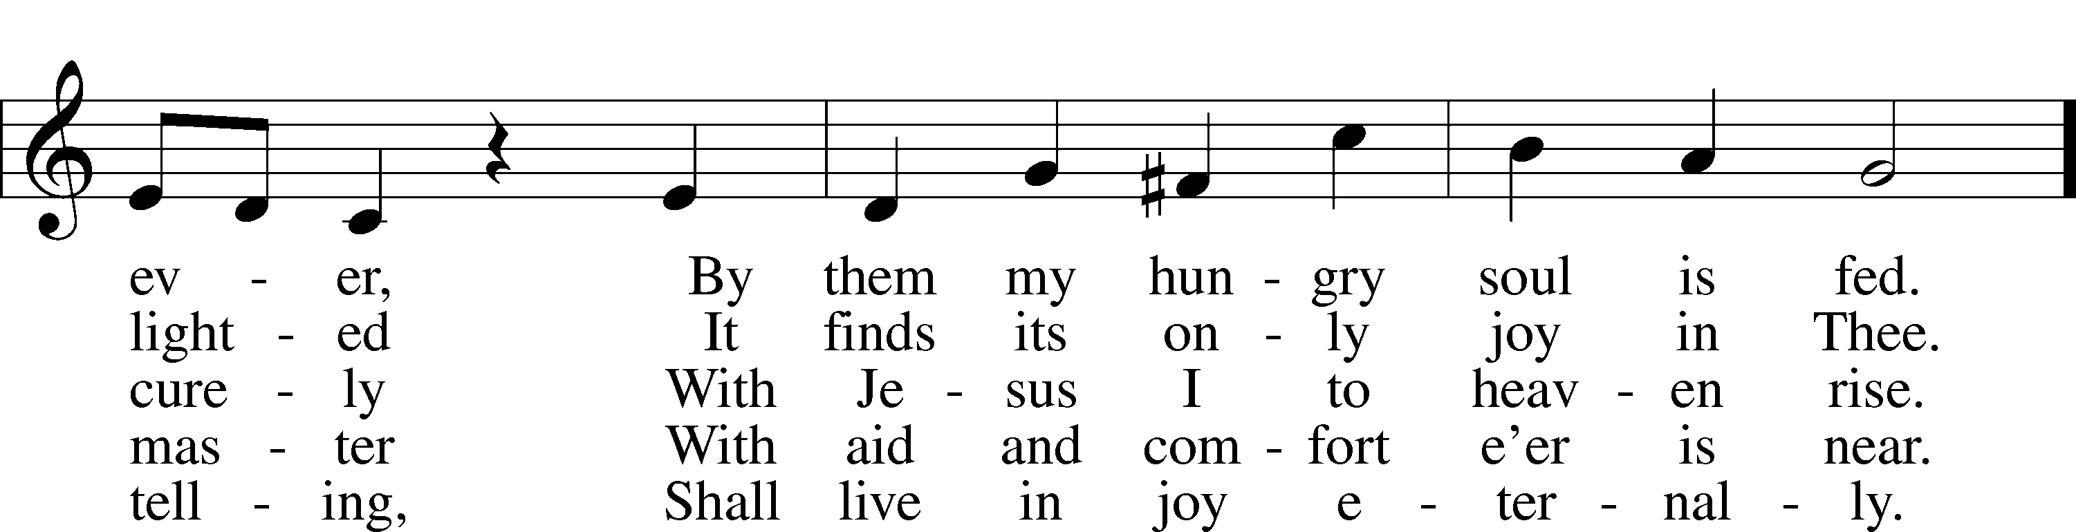
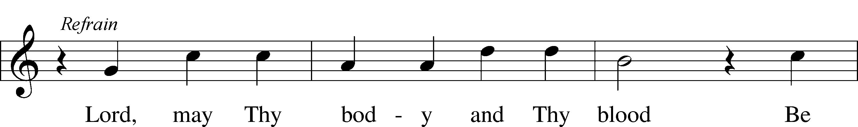

© 1941 Concordia Publishing House. Used by permission: LSB Hymn License .NET, no. 100012179. Public domain

Distribution Hymn: 831 “’How Shall They Hear,’ Who Have Not Heard”
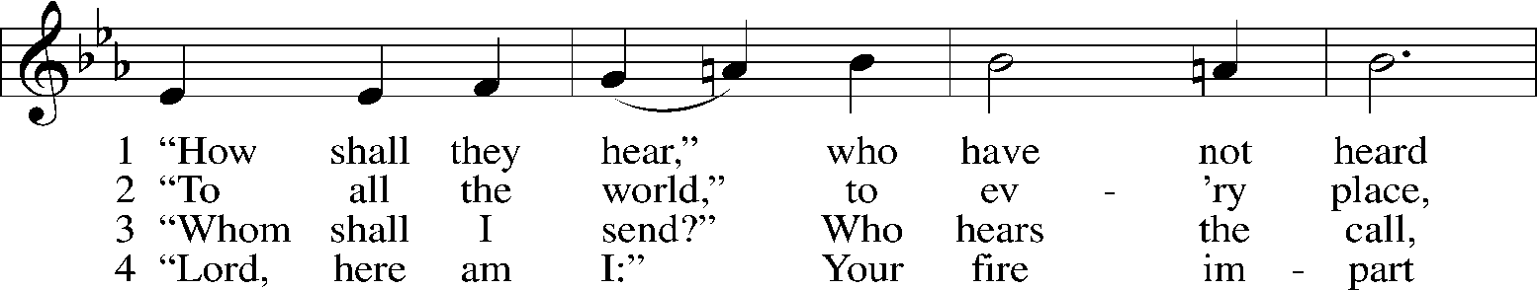
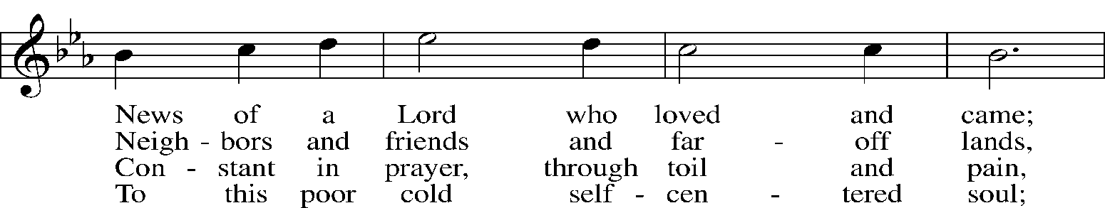
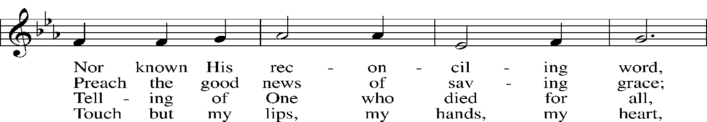
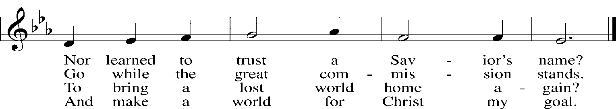

5 Spirit of love, within us move: Spirit of truth, in pow’r come down!
So shall they hear and find and prove Christ is their life, their joy, their crown.
© 1984 Hope Publishing Co. Used by permission: LSB Hymn License .NET, no. 100012179. Public domain

Distribution Hymn: 813 “Rejoice, O Pilgrim Throng”
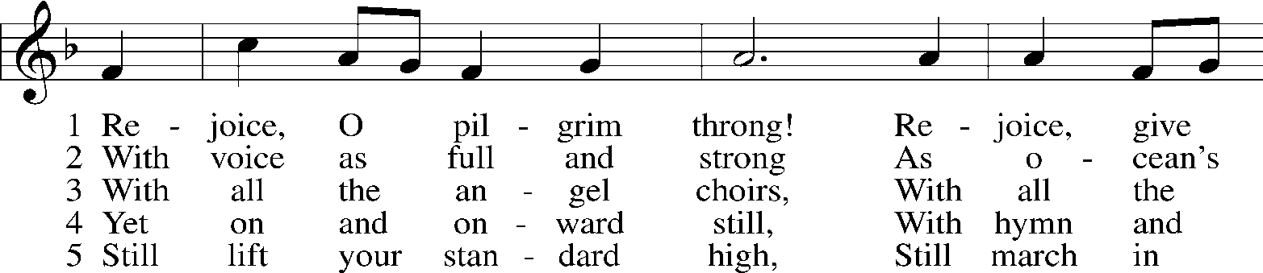
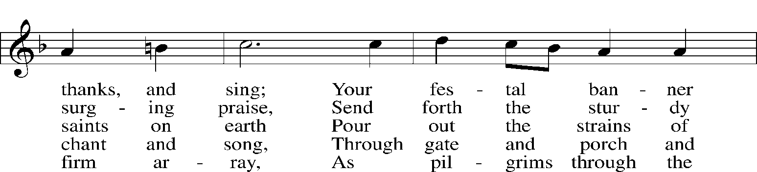
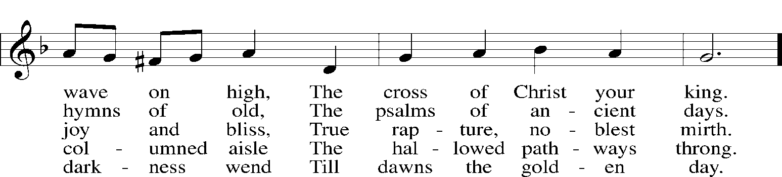
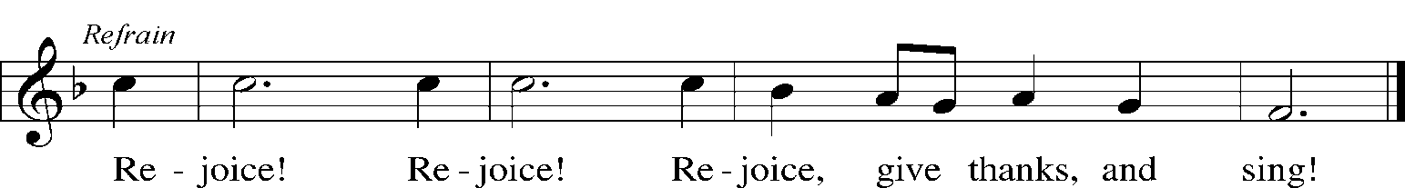

6 At last the march shall end; The wearied ones shall rest;
The pilgrims find their home at last, Jerusalem the blest. Refrain

(please stand for the last stanza if able, sung “A-men.”)
7 Praise Him who reigns on high, The Lord whom we adore:
The Father, Son, and Holy Ghost, One God forevermore. Refrain
Public domain
Nunc Dimittis (sung)
Lord, now lettest Thou Thy servant depart in peace according to Thy word, for mine eyes have seen Thy salvation, which Thou hast prepared before the face of all people, a light to lighten the Gentiles and the glory of Thy people Israel. Glory be to the Father and to the Son and to the Holy Ghost, as it was in the beginning, is now, and ever shall be, world without end. Amen.

Thanksgiving
P O give thanks unto the Lord, for He is good, C (sung) and His mercy endureth forever.
A Let us pray. We give thanks to You, almighty God, that You have refreshed us through this salutary gift, and we implore You that of Your mercy You would strengthen us through the same in faith toward You and in fervent love toward one another; through Jesus Christ, Your Son, our Lord, who lives and reigns with You and the Holy Spirit, one God, now and forever.
C (sung) Amen.

Salutation, Benedicamus and Benediction
P The Lord be with you. C (sung) And with thy spirit.
P Bless we the Lord. C (sung) Thanks be to God.
P The Lord bless you and keep you. The Lord make His face shine upon you and be gracious unto you. The Lord lift up His countenance upon you and (+) give you peace.
C (sung) Amen, amen, amen.

CLOSING HYMN: 826 “Hark, the Voice of Jesus Crying”
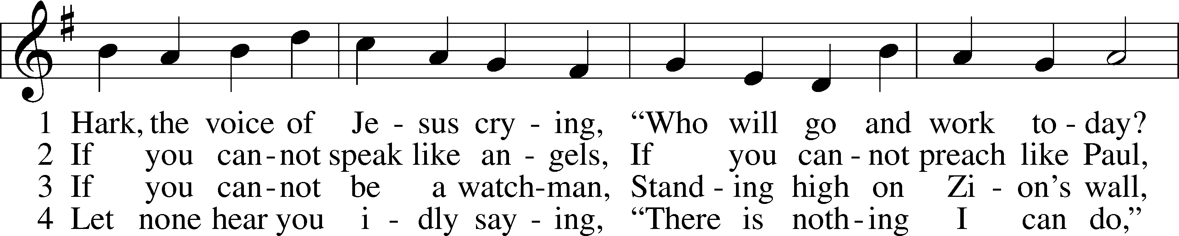
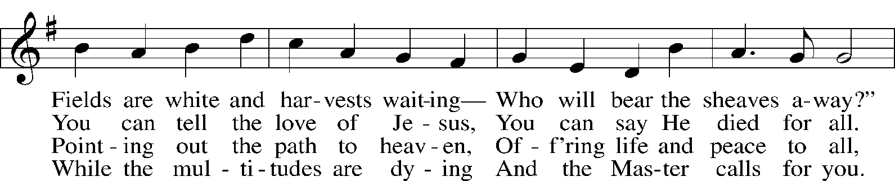
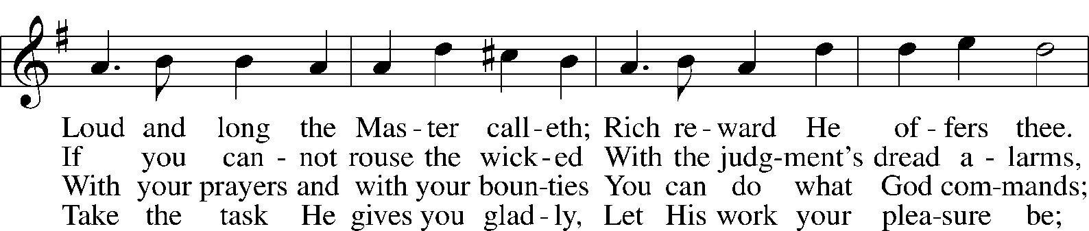
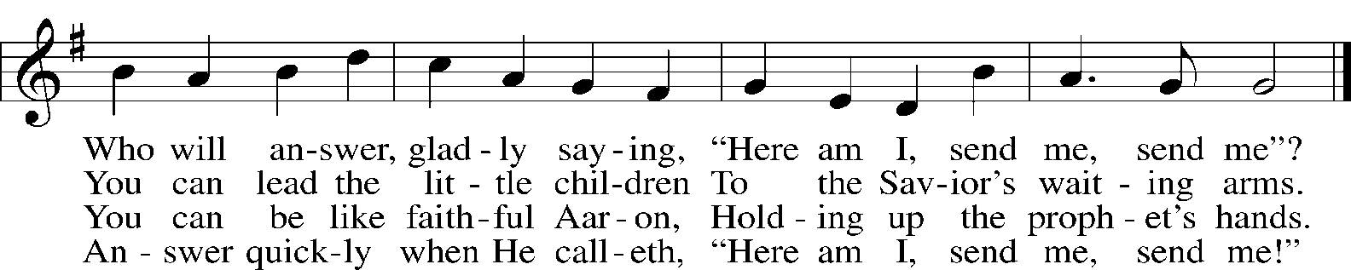
Public domain

THE POSTLUDE: “Dance” arranged by J. Wayne Kerr
Acknowledgments Divine Service, Setting Three from Lutheran Service Book; Unless otherwise indicated, all scripture quotations are from The Holy Bible, English Standard Version, copyright © 2001 by Crossway Bibles, a division of Good News Publishers. Used by permission. All rights reserved. Created by Lutheran Service Builder © 2006 Concordia Publishing House.

This Week With Our Lord, August 16-23, 2020
SUNDAY, August 16-
8:00 a.m. Divine Service with Holy Communion
9:30 a.m. Adult Bible Class in the Fellowship Hall
10:30 a.m. Divine Service (Alternative) (live on Facebook)
Monday, August 17- First Day of School!
Tuesday, August 18-
12:30 p.m. Quilting in the Fellowship Hall
Wednesday, August 19-
8:30 a.m. Opening School Service for Grades 3-8 in the new gym
9:00 a.m. Quilting in the Fellowship Hall
9:30 a.m. Office Staff meeting
7:30 p.m. Bible Class in the Fellowship Hall (Judges)
Thursday, August 20-
8:10 a.m. Bible Class in the Fellowship Hall (Luke)
2:00 p.m. “At-risk” or “vulnerable” Holy Communion Service in the church
Friday, August 21-
8:30 a.m. Opening School Service for Preschool-2
Saturday, August 22-
5:00 p.m. Divine Service Acolyte: Chase Lucht
SUNDAY, August 23 -
8:00 a.m. Divine Service Acolyte: Dylan Minemann
9:30 a.m. Adult Bible Class in the Fellowship Hall
9:30 a.m. Sunday School Rally Day outside of school (weather permitting)
10:30 a.m. Divine Service with Holy Communion (live-streamed on Facebook)
Acolyte: Dustin Salger
11:00 a.m. Class of 2021 BBQ in the school parking lot
THE LUTHERAN HOUR:
Believing in Jesus Christ, we truly see things the way they are. It is "Archives August." Listen to “Seeing Is Believing” (John 20:29) with former Speaker Dr. Dale Meyer on KFUO AM 850 Sunday at 12:30 & 5 p.m. or on Bott Christian Radio Sundays at 8 a.m. (KSIV 1320 AM or 91.5 FM).
FLOWERS IN THE CHANCEL:
To have flowers in worship please call the office at 282-3873 to notify the committee and to have proper thanks in the bulletin of those donating.
OUR RESPONSE TO THE GOSPEL LAST WEEK:
Worship: 245; Holy Communion: 71; Adult Bible Class: 24
WE GIVE THEE BUT THINE OWN, WHATE’ER THE GIFT MAY BE:
We join with one another in the grace of giving. 8/9- General Fund: $11,075; School- $930; Debt: $150. “Bring the full tithe into the storehouse, that there may be food in My house. And thereby put Me to the test, says the Lord of hosts, if I will not open the windows of heaven for you and pour down for you a blessing until there is no more need.” (Malachi 3:10)
STEWARDSHIP THOUGHTS: LCMS Stewardship Resources
Matt. 15:27 – “Yes, Lord, yet even the dogs eat the crumbs that fall from their masters’ table.” These are the words of faith, for faith means receiving what God gives. And God has given us so much more than just the crumbs that fall from the table. He has given us life and salvation, body and soul, eyes and ears, possessions and income. Our stewardship starts with faith in the God who is the greatest Giver.
ADULT BIBLE CLASS:
Sunday morning Adult Bible Class continues this weekend between services, 9:30 to 10:15 a.m. in the Fellowship Hall. We are studying the New Testament book of Acts. Coffee and refreshments are being served.
SUNDAY SCHOOL:
Rally Day will be held next Sunday outside (weather permitting) behind the school building (use E. S. 6th Street as the drop-off and pick-up point). Classes will begin in the new gym and lobby on Sunday the 23rd.
SPECIAL HOLY COMMUNION SERVICE:
We will hold another “at-risk” or “vulnerable” Holy Communion service this Thursday, August 20, at 2 p.m. in the sanctuary. Please wear a mask and sit with an empty pew in between. The service will be shorter and communion will be distributed in the pews.
SECRET ANGELS:
With a new school year starting our 8th grade students (day school and public school) are in need of Secret Angels. These are people who will pray for them, give then notes to encourage them in their confirmation studies and bless them with small gifts on a regular basis and special presents and major occasions. Your identity will be revealed to them at the Rite of Confirmation. Please contact Pastor Nebel if you are interested in serving in this way. He will be able to provide you with an information form that the students have completed.
LIFELINE SCREENING:
The rescheduled Lifeline Screening will be held in our Fellowship Hall on Friday, August 28. Please remain in your vehicle in the parking lot until the time of your appointment to avoid having extra people in the building. Thank you!
LILYFIELDS MUSIC CDs AVAILABLE:
St. John’s member Joan Voges is offering the latest, and last, music CD from her Lilyfields Collection to us for a donation to our school’s ministry. “Peter’s Song” tells the story of Jesus through the eyes of His disciple Peter. The seven tracks of this CD include beautiful narrations from the late Chris Bergmann along with Joan’s texts and tunes. Please see Joan after worship today to pick up a copy of this compact disc.
SCHOOL HANDBOOK ADDITION:
This past week our Board of Elders approved this policy and the Board of Parish Education approved the following addition to our school handbook:
Members of St. John’s Lutheran Church whose children attend St. John’s Lutheran School under non-tuition member status do so with the intent and desire to have their children educated in the Christian faith so as to take part in the Rite of Confirmation and become communicant members of St. John’s Lutheran Church. Parents who do not wish their children to participate in the Rite of Confirmation at St. John’s Lutheran Church will enroll their children as tuition-paying students.
COLLEGE CAMPUS MINISTRIES:
Recent data from the Synod's Office on Youth Ministry confirms that we lose many young people when they move away from home for college. Lutheran Student Ministry aims to provide opportunities for Bible study and pastoral care to students during this time of transition. Our district has campus ministries at both SIU campuses. Our college-student members are invited to call our office for help in connecting with a Lutheran campus ministry for the college they will be attending. Rev. Michael Schuermann serves University Lutheran Church in Champaign for the students at University of Illinois and Parkland College. You can reach him at 217/299-2353 or https://uniluchampaign.org/referral.
THE PRAYER CHAIN:
Vickie Heller is our Prayer Chain Coordinator. If you would like to serve in the Prayer Chain or if you have a prayer request, please contact Vickie at 618/521-7417 or dvheller@htc.net. Call the church office if you would like to add someone to our worship prayers. Confess your sins to each other and pray for each other so that you may be healed. The prayer of a righteous man is powerful and effective (James 5:16).
PLEASE PRAY FOR OUR FAMILY OF FAITH AT:
Red Bud Care Center: Virginia Bahr, Melba Liefer, Gloria Stellhorn, Wilma Wagner, Jody Winkelmann; Waterloo Garden Place- Alice Smith; Ruma R&R- Fern Schnepel, Willard Uffelmann; Waterloo Magnolia Terrace- June Lawrence; Cedarhurst Memory Care, Waterloo- Cecelia Lautenschlaeger
PLEASE PRAY FOR OUR FAMILY OF FAITH AT RED BUD GARDEN PLACE:
Margaret Hanebutt, Dorothy Heizer, Omer and Neva Liefer, Vernon and Evelyn Muench, Lorine Reinhardt, Dr. Paul Schrieber, Wilma Stellhorn, Norma Vogt, Arlin and Helen Winkelman
PLEASE PRAY FOR OUR FAMILY OF FAITH CONFINED IN-HOME:
Kathryn Chunn, Larry Ebers, Don and Betty Fausz, Willie Guebert, Nancy Holmstrom, Kenneth Koester, Donald Kueker, Joyce Lopez, Jean Menke, Edna Moeller, Elda Seders.
HAPPY BIRTHDAY!:
8/16- Wilma Stellhorn, Joyce Lopez, Dion Chandler, Ty Voss; 8/17- Kenneth Lohman, Rex Roehrkasse, Scott Liefer, Angela Junge, Alexander Voges, Cody Hess; 8/18- Leonard Koester, Randy Miller, Darren Liefer, Zachary Heaton, Cameron Jackson, Carter Maloney; 8/19- Brian Guebert, Gil Stellhorn, Julie Falk, Lanie Pensoneau, Tobias LaChance; 8/20- Melba Liefer, Kevin Zeiger, Alyssa Cowell, Logan Cowell; 8/21- Pam Miller, Jason Langrehr, Chris Schield, 8/22- Viola Muench, Elsie Miller, Rebecca Junge. Please call the office for corrections!
KFUO AM 850 LUTHERAN RADIO:
KFUO Radio, AM850 & kfuo.org, a media ministry extension of LCMS congregations, shares Christ for you on AM850 & kfuo.org via worship services, Bible and theology studies, practical talk programs, and sacred music. You can find programs on demand at kfuo.org and wherever you get podcasts! Find us on social media @KFUO.org, Facebook, Twitter, and Instagram. This week on KFUO AM850 & kfuo.org, begin the book of Ruth on Sharper Iron (weekdays at 8:00 a.m.), hear about how trust affects mental health with Deaconess Heidi Goehmann on The Coffee Hour (8/17 at 9:00 a.m.), and study 1 Corinthians 9-12 on Thy Strong Word (weekdays at 11:00 a.m.). Find these programs on demand at kfuo.org or wherever you get your podcasts.
ISSUES, ETC.:
Issues, Etc. is a radio talk show and podcast produced by Lutheran Public Radio in Collinsville and hosted by LCMS Pastor Todd Wilken. This week’s topics include: Online Political Conversations, 17th Century Lutheran Theologian Johann Gerhard, 11th Century Hymnwriter Bernard of Clairvaux, Old Testament Judge Samuel and more. Tune in live weekdays from 3-5 p.m. on KFUO, 850 AM in St. Louis. Listen at your convenience at issuesetc.org, the LPR mobile app and your favorite podcast provider.
LIFE THOUGHTS: (from Lutherans for Life) www.lutheransforlife.org
Jesus didn’t really see the Canaanite woman as less than human (Matthew 15:21-28). He compared her to a dog but also called all the Israelites sheep. Many Jews did treat Gentiles like animals, though. No doubt they took close note when He included her and her little girl among the children of God. It’s like someone today saying fetuses count as human beings or elderly lives matter as much as the rest of us.

CHRIST OUR SAVIOR LUTHERAN HIGH SCHOOL 618-853-7300
Be a Soldier! Registrations are still being accepted for all classes for 2020-2021. The first day of classes is August 18. For information, contact Matthew Foster, mfoster@coslhs.org or call the school office.
School Visitors: To comply with new regulations, visitors are asked to contact the school to make an appointment for a visit or for deliveries. Face coverings are required for entry into the school. We are asking for your patience, prayers and understanding as we strive to do our very best to protect our students, faculty, staff, and you.
School Hours: Regular office hours have resumed. The office will be open Monday – Friday from 8 a.m. – 4 p.m.
The mission of Christ Our Savior Lutheran High School is to provide a Christ-centered and academically excellent education.
St. John’s Lutheran Church – LCMS

508 Bloom Street, Red Bud, Illinois
Church Office & School: 808 South Main Street
(618) 282-3873 Fax 618-282-4087
E-mail: office@stjohnsredbud.org Web address: www.stjohnsredbud.org
Senior Pastor Mark Nebel 618-237-5802 or home 282-3050
Principal – Mrs. Deitt Schneider 618-806-3049 or home: 824-6335
Director of Parish Music – Mrs. Lindsey Hudak 340-6055
Director of Christian Education and School Librarian – Mr. Bill Becker 282-2958
Athletic Director – Justin Palm 214-1103 Secretaries - Julie Ratz & Jessica Schloemann
Senior Youth – Terry and Susie Harms 618-201-5654
Junior Youth -- Lisa Quinn and Jennifer Roscow 282-5343
Matthew Foster, Principal, Christ Our Savior Lutheran High, 853-7300
Faculty and Staff
Preschool – Cindy Steele
Kindergarten – Betty Schmitz; Aide – Patty Schnepel
First Grade – Rachel Miller
Second Grade – Rebekah Liefer
Third Grade – Stephanie Valleroy
Fourth Grade – Cindy Nebel (Before/After School Care)
Fifth Grade – Darlene Letcher
Sixth Grade Homeroom (6th-8th) – Doreen Schnepel
Seventh Grade Homeroom (6th-8th) – Nancy Whelan
Eighth Grade Homeroom and Athletic Director (6th-8th) – Justin Palm
Resource Teacher – Lara Vause
Custodians – Alan Ohms, Bob Schramm Cooks – Jill Gross and Marilyn Oettle
Day Care
Amanda Falkenhain, Director; Kellie Shields, Assistant Director; Lisa Quinn, Ashley Brittingham, Megan Diercks, Jennifer Pfannebecker, Nicole Kadlec, Patty Brewer, Kristi Martel, Courtney Schoenbeck, Brittney Eichholz, Pam Henry, Eileen Seibold, Christy Deterding, Melissa Schilling, Kaleigh Johnston, and Geraldine Thompson
Church Council
Chairman: Bruce Schneider Vice-Chairman: Gary Buatte
Secretary: Joan Ruwald Treasurer: Ray Wagner Board of Finance: Ben Guebert
Elder Chair: Stuart Langrehr Parish Education Chair: Andrew Stellhorn
Trustee Chair: John Preston Estate Fund Chair: Jim Walker
Lutheran High School Board: Lisa Quinn and Christina Gidley
Serving Us in Worship Today
Preacher and Liturgist: Pastor Mark Nebel Organist: Mrs. Lindsey Hudak
Lector: (8 a.m.) Seminarian Wade Waterstreet; (10:30 a.m.) DCE Bill Becker
Greeters: (5 p.m.) Virginia and Mark Moeller; (8 a.m.) Cindy Steele
Acolytes: (5 p.m.) Olivia Schluter; (8 a.m.) Melayna Crafton; (10:30 a.m.) Trace Wagner
(10:30 a.m.) Instrumentalists: Brandon Nehrt, Lindsey Hudak, Jonathan Hudak
Video: Eric Fritsche Communion Cloths: Lynn Langrehr
Flower Servers: Lisa Quinn and Jennifer Roscow Paraments: Irma Birkner

BIBLE STUDIES:
Check our website under the Media tab for Bible studies that you can do on your own. The topics so far are Amen, Angels, Antichrist, Apostles, Apostolic Preaching of the Resurrection, Baptism Q & A, Barnabas, Church and Homosexuality, Communications Skills, Cremation, Christian Citizenship, Discussing Homosexuality, Ecclesiastes, End of the World, God’s Will in the Lives of His People, Haggai, Having the Right Attitude, Heaven, The Justice of God, Justification and Sanctification, Islam, Live By the Spirit, Malachi, Meditation, Philemon, Purses, Was Jesus a Vegetarian?, Word Dwellers, and more to come!
PARISH NURSE NOTE: from LCMS Better Health

