St. John’s Lutheran School
Calendar 2018-2019
Parent Teacher League
Jesus said, “I am the light of the world. Whoever follows Me will not walk in darkness, but will have the light of life.”
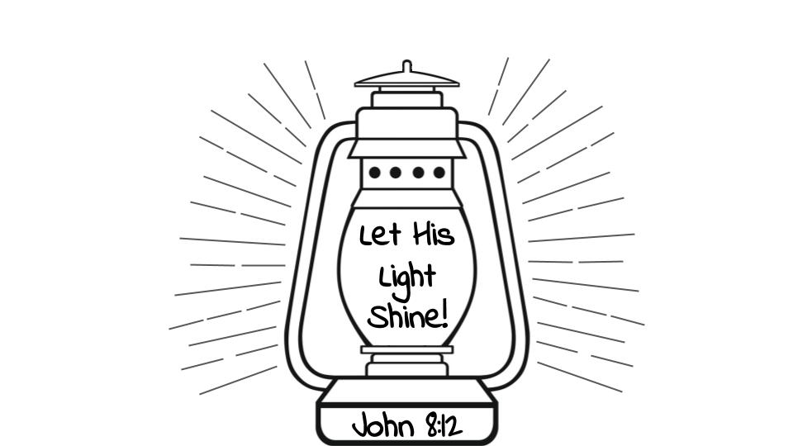
808 South Main St., Red Bud IL
Phone 282-3873 Fax 282-4087
St. Johns Lutheran School Calendar for the 2018-2019 School Year
Dates may be changed for unforeseen reasons. Changes will be published in the weekly Cougar Tracks, the church bulletin and in the epistle when possible.
SEPTEMBER
Sept. 26- Chapel- 4th Grade, Mr. Becker
Sept. 28- EC Chapel- Mrs. Steele
*September Chapel offerings will be donated to UNITY.

OCTOBER
Oct. 1- Fall Pictures
Oct. 2- CC @ Chester Invitational
Oct. 3- Chapel- 5th Grade
Oct. 5- No school- Teacher Institute
Oct. 8- No school/Office Closed- Columbus Day
Oct. 9- CC @ Fort de Chartres (RBHS)
Oct. 9- OVC CC @ Randolph County Lake
Family, Faith, Fellowship Night- 6:30
Oct. 10- Chapel- Mr. Palm
Oct. 12- EC Chapel, Lisa
End of 1st Quarter
7th Grade class Wine Pairing
Oct. 12, 13 & 14- Class of 2019 Cosmic Bowling
Oct. 13- LSA CC State Meet
Oct. 15- GBB A&B vs. Valmeyer, 6pm
Oct. 17- Chapel- Mrs. Schnepel
Early Dismissal, 1:18pm
Oct. 18- Flu Shot Clinic, 2:30 @ School
BBB @ Holy Childhood, 6pm
GBB vs. Holy Childhood, 6pm
Oct. 19- EC Chapel, Chelsea
Fall Festival, 4:30-7:30pm
Report Cards go home
Oct. 22- GBB @ TSJ/ILS, 5:30pm
Oct. 22- 25- BBB PDR “B” Trny.
Oct. 23- Early Dismissal, 1:48pm
Parent Teacher Conf.
Oct. 24- Chapel, Mrs. Schneider
Parent Teacher Conf.
Voters Meeting, 7pm @ Church
Oct. 25- Early Dismissal, 1:48pm
Oct. 26- No School- Parent Teacher Conf.
Oct. 27- GBB vs. Chester Jr. High, 10am
BBB vs. Chester Jr. High, 11:15am
Oct. 29- BBB vs. St. Libory, 6pm
GBB vs. St. Libory, 7pm
Oct. 31- EC Chapel ALL- Mrs. Schmitz
*October Chapel offerings will be donated to Prison Ministry.

NOVEMBER
Nov. 1- BBB, AB&C @ Evansville, 6pm
Nov. 3- Hoops for the Cure
Nov. 5- BBB AB&C @ Steeleville, 5:30pm
Nov. 6- GBB AB&C vs. St. James, 6pm
Nov. 7- Chapel, Mrs. Koen
Nov. 8- BBB AB&C vs. St. Mary’s Chester, 6pm
Nov. 9- EC Chapel, Nicki
Early Dismissal, 11:20 (no lunch or ASC)
GBB & BBB vs. Unity, 5:15pm
Nov. 11- Wurstmarkt, 11am @ School
Nov. 12- PTL Meeting, 7pm
Nov. 13- Fall Picture Retake Day
GBB A&C vs. SPPCS, 6pm
Nov. 14- Chapel, Mr. Becker
Nov. 15-18- BBB “A” Trny @ Good Shepherd
Nov. 15-18- GBB “A” Trny TSJ/ILS
Nov. 15- BBB AB&C vs. Coulterville, 6pm
Nov. 16- EC Chapel, Mrs. Schmitz
Nov. 17- Craft Fair, 11am-4pm
Nov. 19- BBB AB&C vs. PDR, 6pm
Nov. 20- GBB A&C @ Chester Lutheran, 6pm
Nov. 21- Chapel, Grades 1 & 2
Early Dismissal, 1:48pm (NO ASC)
Nov. 22 & 23- No School/Office Closed- Thanksgiving
Nov. 26- BBB “A” @ Trinity, 6pm
Nov. 27- GBB AB&C @ Steeleville, 5:30pm
Nov. 28- Chapel, Mr. Jeff Fick
Nov. 28- Dec. 2- BBB “C” Trny @ RBL
Nov. 29- BBB A&C vs. RBC, 6pm
Nov. 30-Dec. 2- GBB “A” Trny @ Edwardsville
*November Chapel offerings will be donated to Seminary Food Pantry Human Service Center

DECEMBER
Dec. 4- GBB A&C vs. Chester Lutheran, 6pm
Dec. 5- Early Dismissal, 1:18pm
EC (Daycare & Preschool) Christmas Service, 8:30 am and 7pm.
Dec. 6- BBB AB&C @ St. Marks, 6pm
Dec. 7- GBB @ St. Marks, 6pm
Dec. 7 & 8- BBB “C” Trny @ RBC
Dec. 7 & 8- GBB “C” Trny @ RBL
Dec. 11- GBB B&C @ RBC, 6pm
Dec. 12- K, 1 & 2 Christmas Service, 8:30am and 7pm
Dec. 13- BBB AB&C vs. Chester Lutheran, 6pm GBB A&B @ Marissa, 6pm
Dec. 14- GBB AB&C vs. Steeleville, 6pm
Dec. 17- BBB vs. TSJ/ILS, 5:30pm
Dec. 18- BBB A&B vs. RBES, 6pm
GBB B&C vs. RBC, 6pm
Dec. 19- 3rd-8th Christmas Service, 8:30am and 7pm
Dec. 20- GBB A&B @ RBES, 6pm
Dec. 21- Early Dismissal, 1:48pm (NO ASC)
End of 2nd quarter
Dec. 24- Jan 4th- Christmas Break
Dec. 24 & 25- Office Closed
*December Chapel offerings will be donated to Lutheran World Missions.
JANUARY
Jan. 1- Office Closed-New Years Day
Jan. 2-6- BBB & GBB “B” Trny Holy Cross
Jan. 7- School Resumes
Jan. 8-11- BBB OVC Trny
Jan. 11- Report Cards go home
Jan. 12- Class of 2019 Trivia Night
Jan. 15- BBB A&B @ Valmeyer, 6pm
Jan. 16- Chapel, Dr. Bruce McLaughlin
Early Dismissal, 1:18pm
Jan. 17-20- BBB “A” ALT
Jan. 18- EC Chapel, Mrs. Steele
Geography Bee, 1pm
Jan. 19- GBB State Tournament
Jan. 21- No School/Office Closed M.L. King B-Day
Jan. 23- Chapel
Jan. 23 & 25- VB “A” Trny @ RBC
Jan. 28- VB AB&C vs. Valmeyer, 5:30pm
Jan. 29- VB AB&C @ Chester Jr. High, 5pm
Jan. 30- Chapel, Mrs. Koen
Jan. 31- VB @ Coulterville, 4:15pm
*January Chapel offerings will be donated to Armed Forces.
FEBURARY
Feb. 1- EC Chapel, Amanda
Feb. 1 & 2- VB “B” Trny @ PDR
Feb. 5- VB @ PDR, 6pm
Feb. 6- Early Dismissal, 1:18pm
Feb. 7- VB @ Steeleville, 4:15pm
Feb. 8- VB “C” Trny RBES @ RBHS
Feb. 8 & 9- VB “A” Trny @ St. Mary’s
Feb. 11- PTL Meeting, 7pm
Feb. 12- VB @ RBC, 6pm
Feb. 13- Chapel, Mrs. Miller
Feb. 14- VB vs. St. Marks, 6pm
Feb. 15 & 16- VB “B” Trny @ RBL
Feb. 15- Early Dismissal, 11:20am
Feb. 18- No School/Office Closed Presidents Day
Feb. 19- VB @ Chester Lutheran 6pm
Feb. 20- Chapel, Mrs. Schnepel
Feb. 21- VB vs. Evansville, 6pm
Feb. 22- Science Fair
Feb. 22 & 23- VB “A” Trny @ Chester Lutheran
Feb. 23- Class of 2021 Trivia Night
Feb. 26- VB AB&C vs. St. Libory, 5pm
Feb. 27- Chapel, 5th Grade
Feb. 28- VB vs. St. Mary’s Chester, 6pm
*February Chapel offerings will be donated to Hearts of Jesus.

MARCH
March. 1- EC Chapel, Amanda
Early Dismissal, 11:20am- No lunch/ASC
LSA State Cheerleading Competition
March 1, 2 & 3- LSA GBB & BBB State Tournament
March 4- No school/Office Closed Casimir Pulaski
March 5, 6, 7 & 8- VB OVC Trny.
March 6- Ash Wednesday Church Service, 8:30am
March 8- End of third Quarter
March 9- VB “C” Trny @ St. Mary’s
March 11- VB AB&C @ Smithton, 5pm
March 13- Lenten Church Service, 8:30am
March 15- EC Chapel, Mrs. Schmitz
Report Cards go home
March 16- Dinner Auction
March 20- Lenten Church Service, 8:30am
March 22- EC Chapel, Mrs. Steele
March 22 & 23- PTL Rummage Sale
March 25-29- Achievement Testing
March 27- Lenten Church Service, 8:30am
Early Dismissal, 1:18pm
March 29- EC Chapel, Amanda
*March Chapel offerings will be donated to COSLHS.
APRIL
April 3- Lenten Church Service, 8:30am
April 5- Early Dismissal, 11:20 (No lunch or ASC)
School Musical, 7pm
April 9- PTL Meeting, 7pm
April 10- Lenten Church Service, 8:30am
Track, Sr. OVC
April 11- Confirmation Questioning, 7pm
April 13 & 14- Track, RBC Invitational
April 14- Confirmation
April 17- Track, Jr. OVC
April 18- Maunday Thursday Church Service, 8:30am
NO AFTER SCHOOL CARE
April 19- No School/Office Closed- Good Friday
April 20- Track, RBC Invitational
April 22- No School/Office Closed, Easter Monday
April 25- Track, Randolph County
April 27- May 4- 8th Grade Class Trip
*April Chapel offerings will be donated to Life Network.

MAY
May 1- Chapel, Rev. Dan Ostlund
May 8- Chapel, Mrs. Laura Montgomery
May 11- Track SIJHSAA State
Track Lutheran District
May 15- Chapel, Pr. Koen
Sports Award Banquet
May 17- EC Chapel, Mrs. Valleroy
May 18- Track, LSA State
May 27- No School/Office Closed Memorial Day
*May Chapel offerings will be donated to LESA.

**Please remember that these dates and times can always change. Any changes will be posted in the weekly Cougar Tracks and bulletin and monthly Epistles.

Mission Statement
St. John’s Lutheran school provides quality Chirst-centered education for the congregation and community to make and equip disciples of Jesus Christ.

Jesus said, “I am the light of the world. Whoever follows Me will not walk in darkness, but will have the light of life.”

